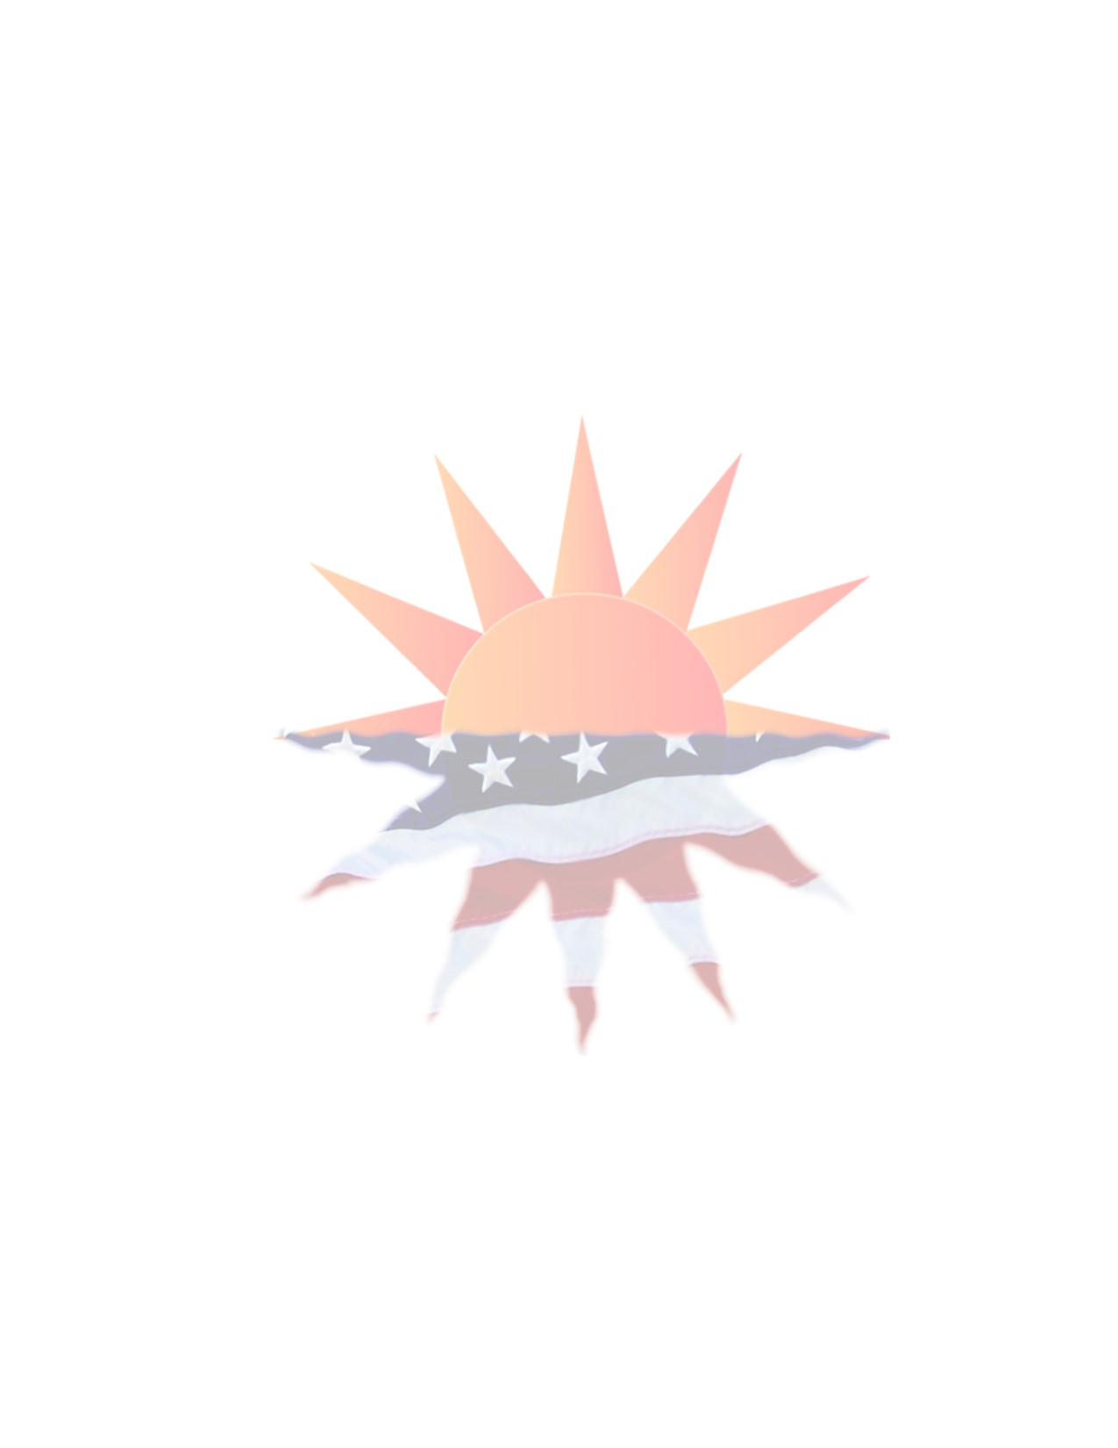
Dear Parade Participant:

Sundown Salute is gearing up for the annual 4th of July Sundown Salute parade. This year’s theme is “Tribute to America.” The parade will be on Thursday July 4th, 2019 and starts at 10:00 am.

**Please note new regulations concerning entries to the parade.

Whether you plan to be judged or not, all entries must be decorated according to this theme or a patriotic theme!

Prizes will be awarded to First, Second, and Third Places. Judging will be done in the staging area so floats can be recognized as the winning floats during the parade. Your cooperation in the staging area and parade route is expected and appreciated.

Your entry is free and we encourage you to be creative for this year’s parade. Remember, you must decorate your entry(s). Please complete the attached entry form and return it to Sundown Salute Parade P.O. Box 287, Junction City, Kansas 66441 or email a copy to sundownsaluteparade@gmail.com. If you have questions, contact Tricia Verschage @ 912-332-2465 or e-mail sundownsaluteparade@gmail.com

**CAR/MOTORCYCLE CLUBS
1. Motorcycle, ATV, and Scooter operators must abide by all City Ordinance and safety laws accordingly during ALL Parades in Junction City, KS
2. Operators of all motorized vehicles to include motorcycles understand that they will be ticketed for any violations of the law while in the parade (this includes any burnouts that may harm spectators from rubber or excessive smoke from tires)
3. ALL motorized vehicle operators are subject to immediate removal from the Independence Day Parade if any Law Enforcement Officer feels they are in violation of the law and that Operator has endangered the safety of the bystanders at the Parade, participants of the Parade, or themselves
4. Penalty for not adhering to these strict guidelines will be harsh and swift – ZERO Tolerance!
5. Motorcycle Clubs/Organizations or Car and Truck Clubs/Organizations will forfeit the privilege of future applications in ANY parade held in Junction City

**Throwing candy and passing out items

- Throwing candy and other items from vehicles or floats is prohibited.
- Candy and items may be passed out but should be done by participants walking at the edges of the parade route.
- This is done in an effort to keep spectators from coming into the path of vehicles and floats on the parade route.
- This policy will be strictly enforced and violators will be removed from the parade and will no be allowed to participate in future parades.

**PLEASE NO Stopping and Performing on the Parade Route
2019 SUNDOWN SALUTE
PARADE ENTRY FORM
JULY 4, 2019

Entries for the Annual Sundown Salute Parade, scheduled for July 4th, 2019, are now being accepted. There is NO FEE to enter. The theme for this year’s parade is “Tribute to America” and prizes will be awarded to First, Second, and Third Places for those entries that best express the theme.
Whether you plan to be judged or not, all entries must be decorated according to this theme or a patriotic theme!
The entry deadline is June 18th, 2019. You will receive your parade line-up number and line-up time approximately one week before the parade. Do not request a specific line-up number. If you do not receive the line-up information by June 28th, please contact Tricia Verschage @ 912-332-2465 or email sundownsaluteparade@gmail.com.
Please complete the bottom section of this form and return it to:
Sundown Salute Parade
P.O. Box 287
Junction City, KS 66441
E-Mail: sundownsaluteparade@gmail.com

PERSON RESPONSIBLE FOR ENTRY
NAME: |  |  |  |  |  |  | ADDRESS:
CITY: |  |  |  |  | STATE: |  |  |  | ZIP: |  |  |  | PHONE #:
EMAIL: |  |  |  |  |  |  |  |  |  |  |  | Cell Phone#___________
NAME OF ENTRY:
ENTRY CATEGORY: (Please circle one) |  |  |  |  |  |  | JUDGED ENTRY |  |  |  |  |  | NON-JUDGED ENTRY
SIZE OF PARADE ENTRY:
(Give exact length of your entry or number of vehicles. This will ensure you have sufficient space at the staging area)
NUMBER OF PEOPLE WALKING IN YOUR ENTRY:
WILL YOU BE GIVING CANDY/ OR GIVING HANDOUTS:
(Remember no candy will be thrown from vehicles or floats)
*******PLEASE NOTE: The smooth line-up of a parade this size requires the full cooperation of ALL PARTICIPANTS. Vehicles not in the parade will not be allowed into the staging area. NO EXCEPTIONS. Please make arrangements for all heavy equipment, decorating items, persons, etc., to be loaded in the parade vehicle at a location other than the staging area. The playing of audio equipment MUST NOT annoy your neighbors. To prevent unnecessary delays, any uncooperative participant(s) will be removed from the parade line-up.

_____ I have read and understand and will follow all guidelines set forth on the previous pages.

_____________________________________ ___________________________________
Signature of Person Responsible for Entry Print Name

